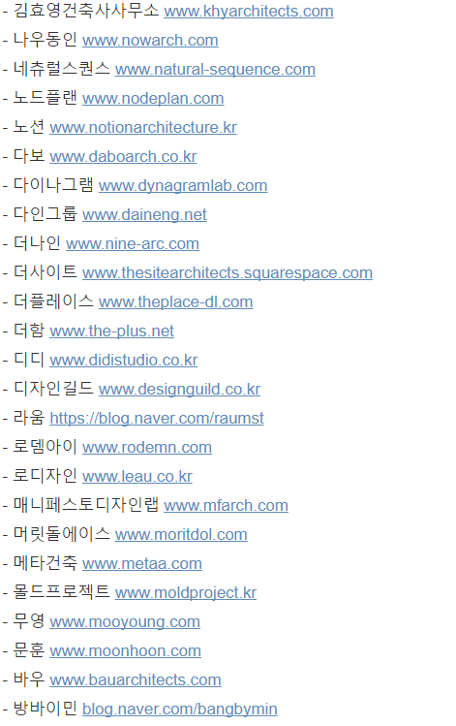
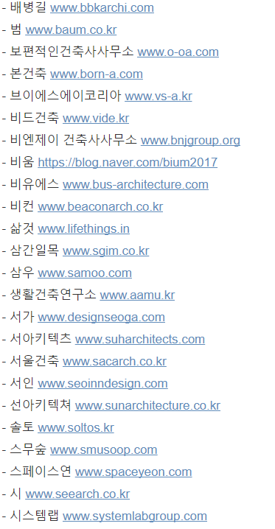
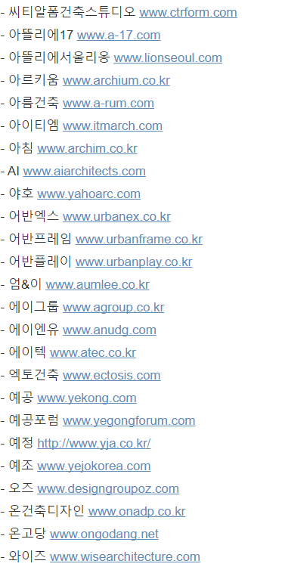
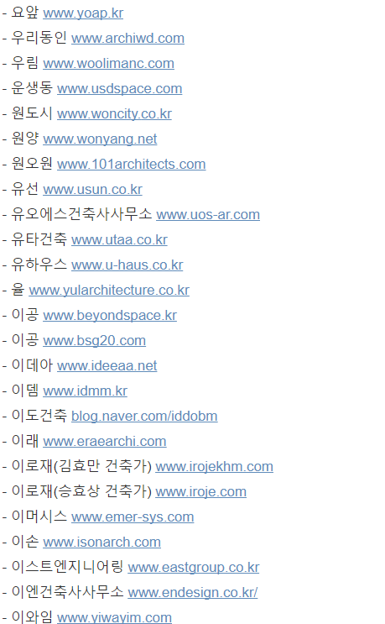
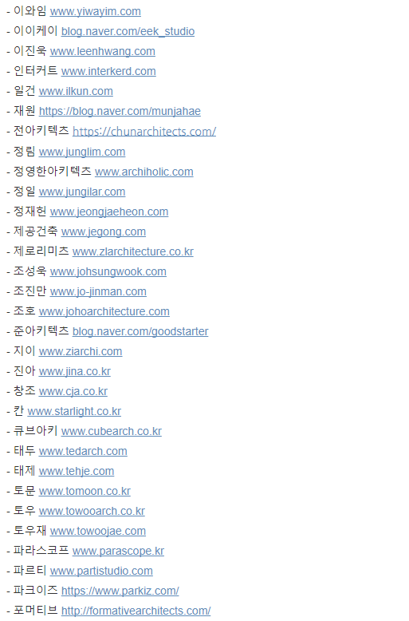
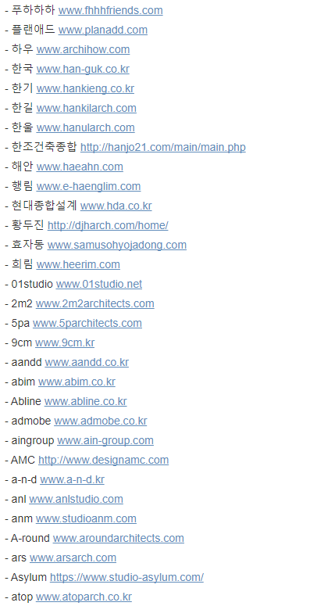
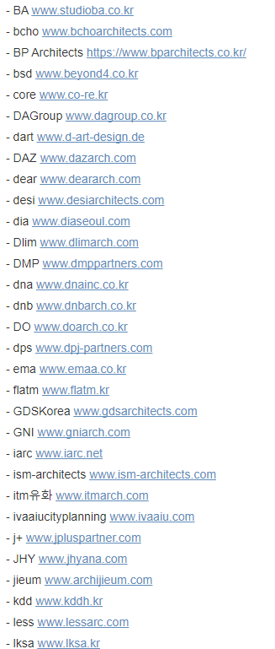
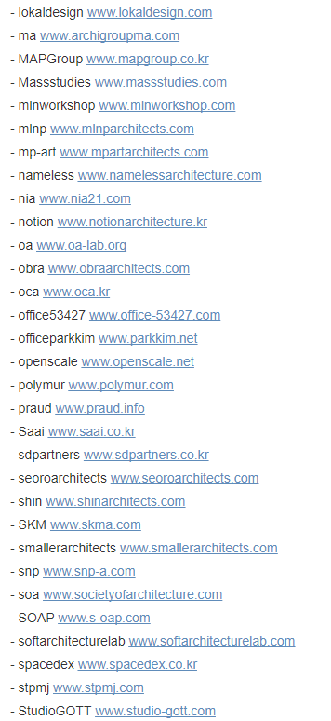

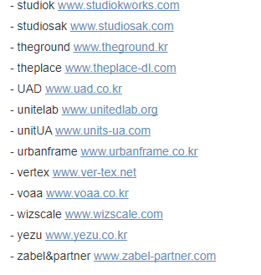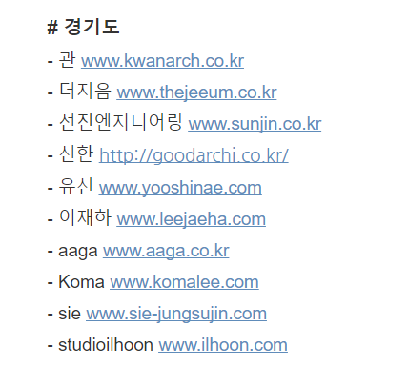

인천
-아벨종합건축사무소 www.abel.ne.kr
-POSCO-A.C www.poscoanc.com
-청마 www.achicm.com
-BH www.bh-arch.com
-디엠에이 www.dmaarchi.com

강원도
-앤탑blog.daum.net/ntoparc
-예담blog.daum.net/pine2000
-시에나 www.studionn.blog.me

광주
-유탑 www.u-top.co.kr
-migaon www.blog.naver.com/migaon-archi
-예가 www.yegadesign.net
-휴먼플랜 www.reportworld.co.kr
-포유 https://skinnara.co.kr/?html=board.view&M_SEQ=2122991
부산
-가가 www.kaga21.com
-리을도랑 www.riduldorang.com
-상지 www.sangji21c.co.kr
-이아 www.iiaa.co.kr
-일신 www.ilshinarch.co.kr
-coreano www.coreano.co.kr
-라인 www.line-architecture.com
-아키키스 www.아키시스.com

대구
-동우E&C www.dongwooa.com
-인아크 www.inark.co.kr
-청연e&c www.blog.naver.com/chungyeon2017
-더 솔 www.the-sol.co.kr

울산
-본 www.blog.naver.com/2725552
-이수 www.arch2su.com
-티에스 www.tsarch.modoo.at

