Ajou International Day 2015
Promotion

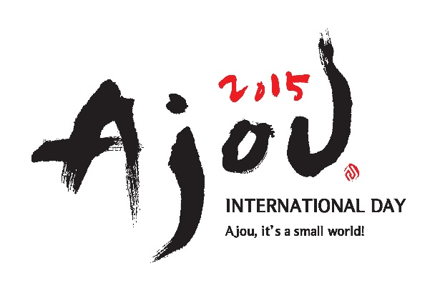
Every fall semester, Ajou University hosts an annual Ajou International Day festival on a day in the first week of November. This is one of Ajou’s biggest festivals of the year which offers a meeting ground for all the international and domestic students on campus. It provides a wide range of activities, including an international food festival where the students prepare and serve dishes unique to their countries and some showcase costumes, music, and performances. Students are able to provide information and exhibit photographs displaying different aspects of their countries’ culture.
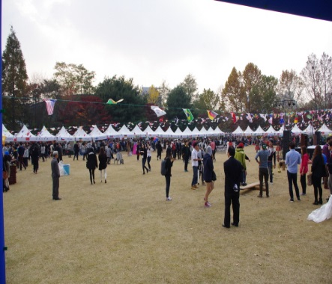
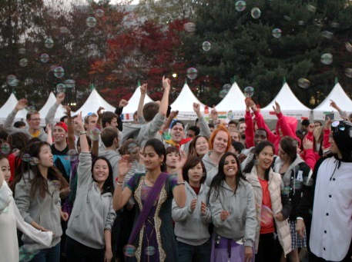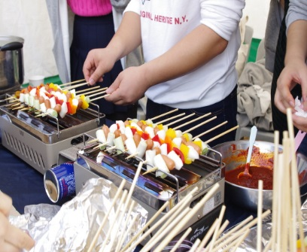
If you bring some items showing your tradition, country, or university, you can enjoy the International Day more. It is recommended to bring some traditional costumes, instruments, flags and leaflets showing your countries or universities.

