NEXT GENERATION PCR: DROPLET DIGITAL PCR FOR RAPID, ACCURATE AND MULTIPLEXED-DIGITAL QUANTIFICATION
Dong-Ku Kang
Department of Chemistry, Incheon National University
(e-mail: dkkang@inu.ac.kr)

Droplet-based microfluidics (DMF) have been developed as a digital assay that allow precise and absolute quantification of targets such as enzyme, bacteria and nucleic acid. To achieve single-molecule detection of DNA/RNA, protein or cell within complex biological samples, each single molecule can be encapsulated into picoliter-volume droplets (microcapsules) using microfluidic device. Various biosensing systems have been also developed and integrated with DMF for the monitoring of various biological-disease markers such as mutant DNA/RNA or enzyme activity. For example, enzyme-linked immunosorbent assay was integrated for the absolute and digital quantification of target protein without standard curve. Among DMF-based analytical approaches, droplet digital PCR (ddPCR) has become most successful example after commercialized by Biorad, Thermofisher and Qiagen. Those conventional digital PCR systems provide more accurate and sensitive diagnostic tool comparing 2nd generation PCR system (which is known as real-time PCR) for the monitoring of gene mutation specially when their ratio is extremely low against wild-type gene within sample. Here we would like to discuss about current developments, applications and future of the digital PCR system.
.
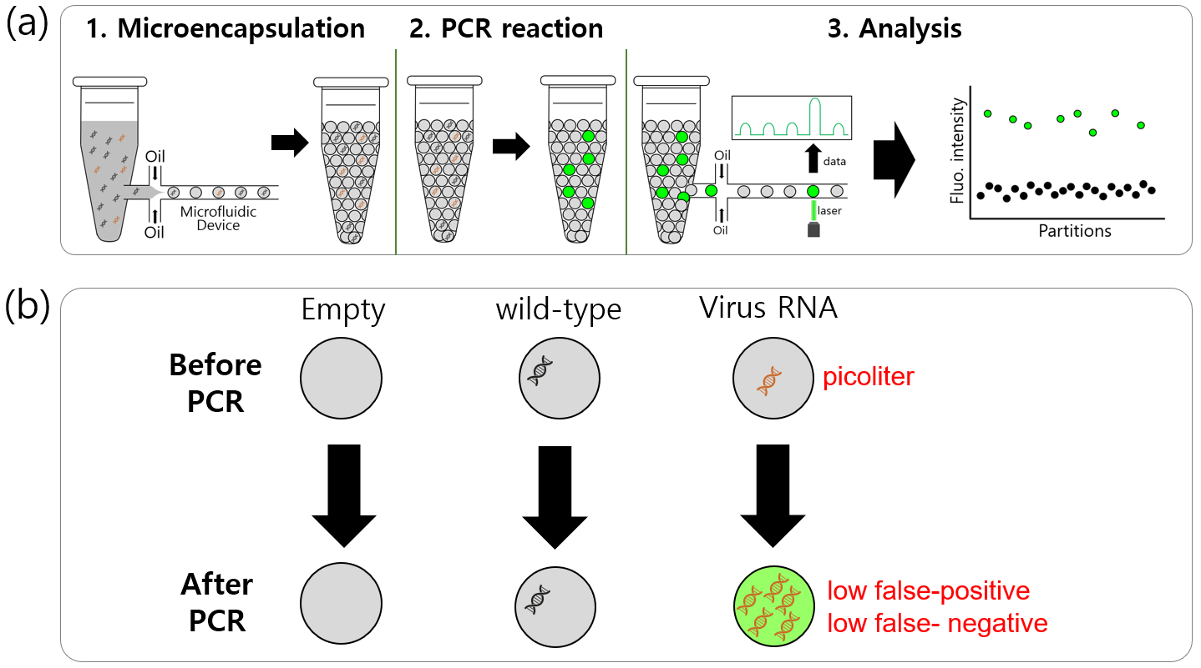
Figure. Next-generation PCR: Droplet Digital PCR. (a) Procedure of droplet-based digital PCR, (b) Concept of droplet-based digital PCR

