2014 Winter KFPP Global internship

KFPP is a public foundation within Korean Ministry of Education. KFPP contributes for the promotion of private school by supporting educational environment improvement business of private institutes. KFPP takes responsibility for the future of the education in Korea.

❍ Program details
• Internship period : 2014.01.02 ~ 2014.01.29 (20 days)
• Duty hour : 5 days in a week for 40 hrs (09:00 ~ 18:00)
• Number of employment : 2
• Work place : KFPP (near the Seocho station, not providing accommodation)
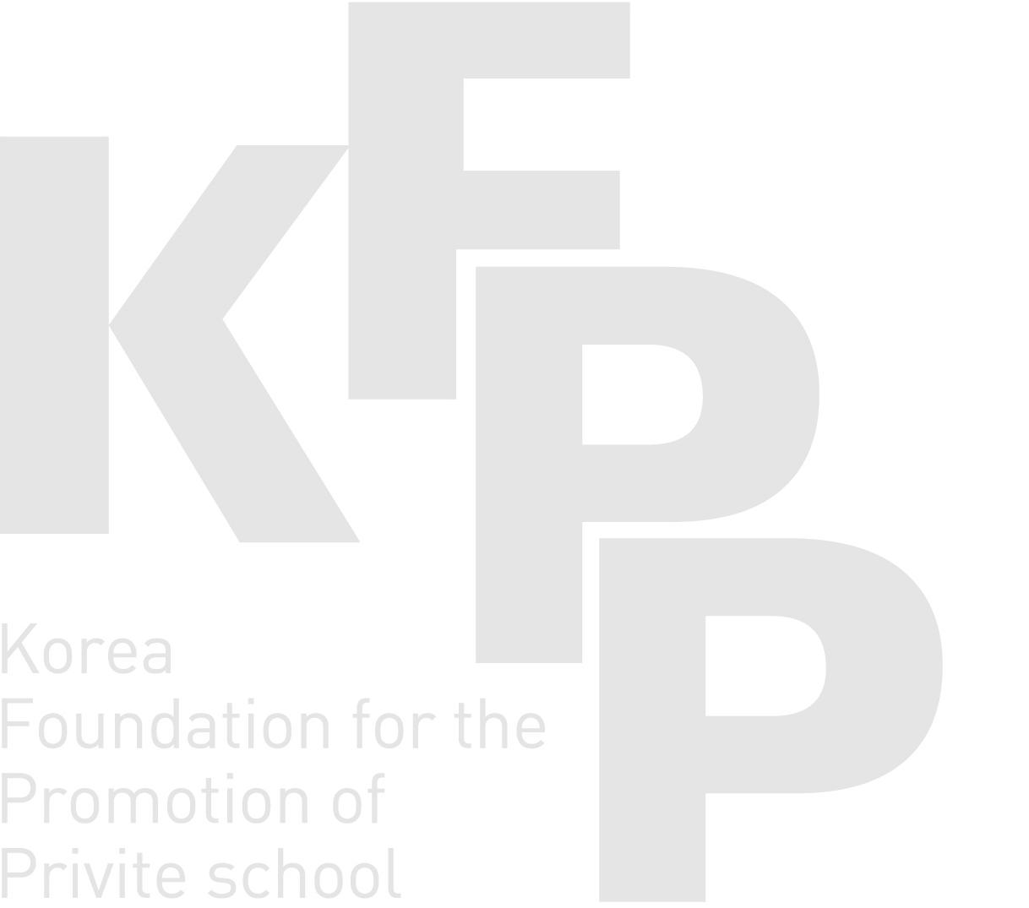
• Duty
- Eligible to speak Spanish : Tasks are related to assisting in writing a proposal about Chile National Scholarship program, writing Argentine Scholarship program evaluation report
- Eligible to speak Portuguese : Tasks are related to the translation of English brochure into Portuguese, to the assistance of internship recruitments of Korean companies
• After completing, Internship certificate will be issued.

❍ Eligibility
• Holding a foreign nationality
• Having enrolled in a full-time course at a Korean university (Exchange student is also eligible)
• As of the applying date, holding D2 visa(Valid till January 2014)
• Fluent in Portuguese or Spanish

❍ How to apply
• Prepare required documents and email them.
1. English resume and cover letter (an essential picture on the resume)
2. A certificate of enrollment in a Korean university
3. A reference from a professor of the enrolled Korean university
4. Copy of a passport,
5. Copy of a alien card
• E-mail : kwakgi@sahak.or.kr (Ms. Gain Gwak)
• Due date : December 23rd, 2013 (by 5 p.m.)

❍ Selection process
• Submit the application : December 23rd
• Review the application and announce the list of interviewee : December 24th
• Conduct the Interview : December 26th

❍ Payment
• The goal of Internship program is offering opportunity of public institution.
• You can get totally 880,000 KRW during the internship period.

❍ Address (Work place)
Global assistance for Universities TF team, 5F KFPP 19 41gil Seochodaero, Seocho-gu, Seoul, Korea ☎ 02) 3479-2578

